Holocaust Survivor Day 2023 Promotional Toolkit
Everything you need to promote your events on Holocaust Survivor Day.

Holocaust Survivor Day is a day to celebrate the bravery, sacrifices, and lives of survivors.

We believe that Holocaust Survivors are our teachers, but the responsibility of passing on the legacy of their testimonies lies with all of us.

On June 4th, 2023, organizations from around the world will come together to celebrate survivors. Each organization and community will hold their own events locally, but together, we will celebrate those who survived.
You can learn more and sign up as a partner by visiting our website.
General Brand
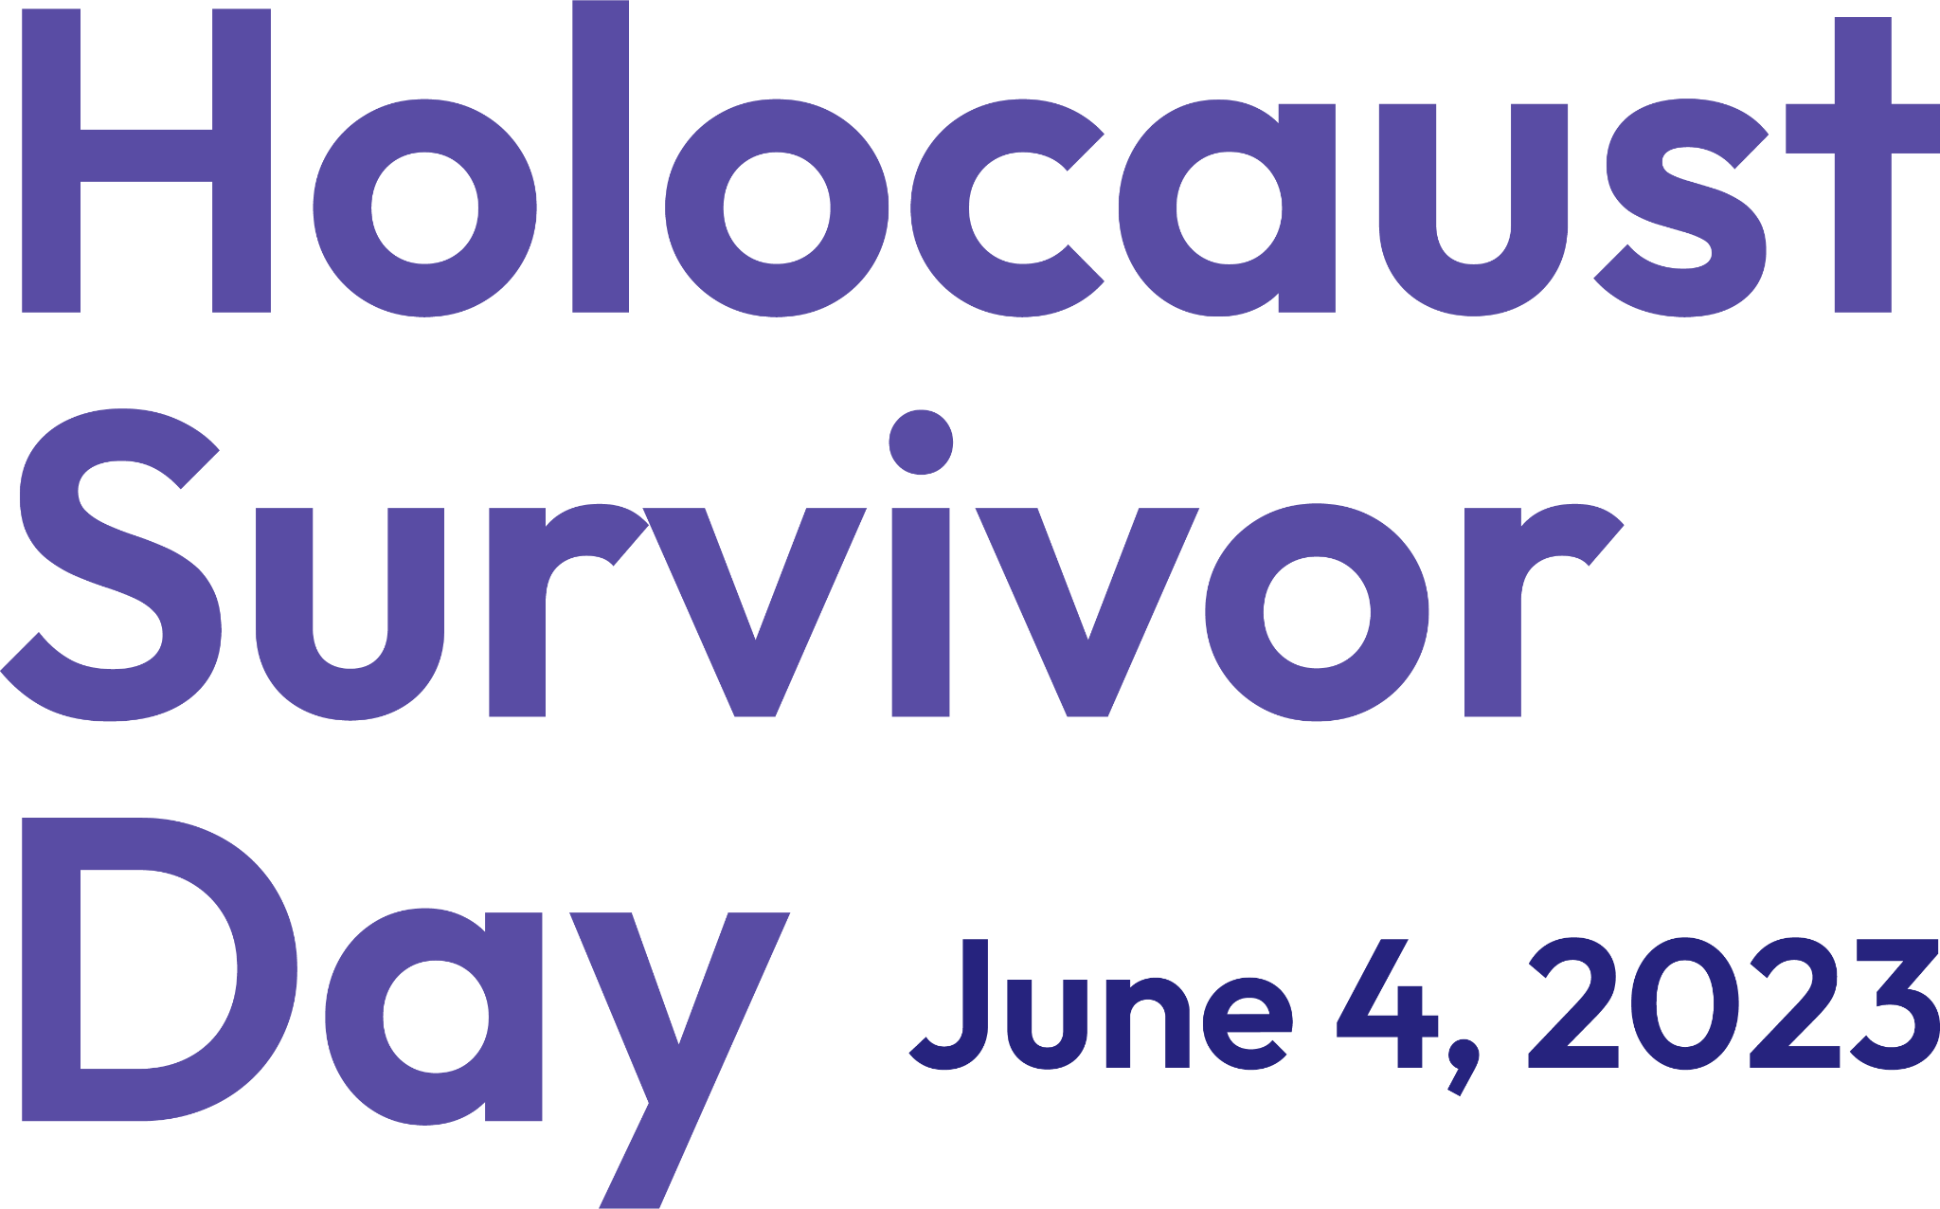
Find the style guide and download links, here.
Find curated and usable photos, here.
Social Posts
We have created social media assets for posts and stories across various platforms. Use #HolocaustSurvivorDay in your posts!
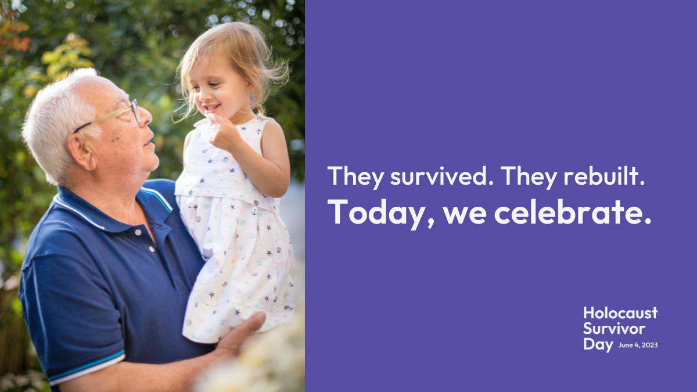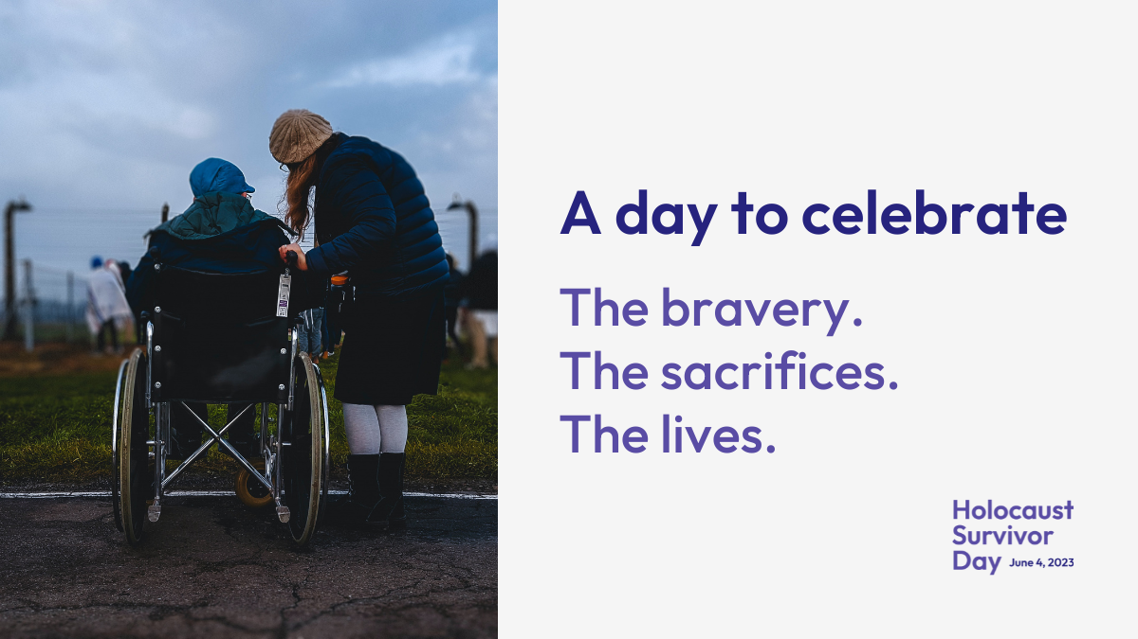
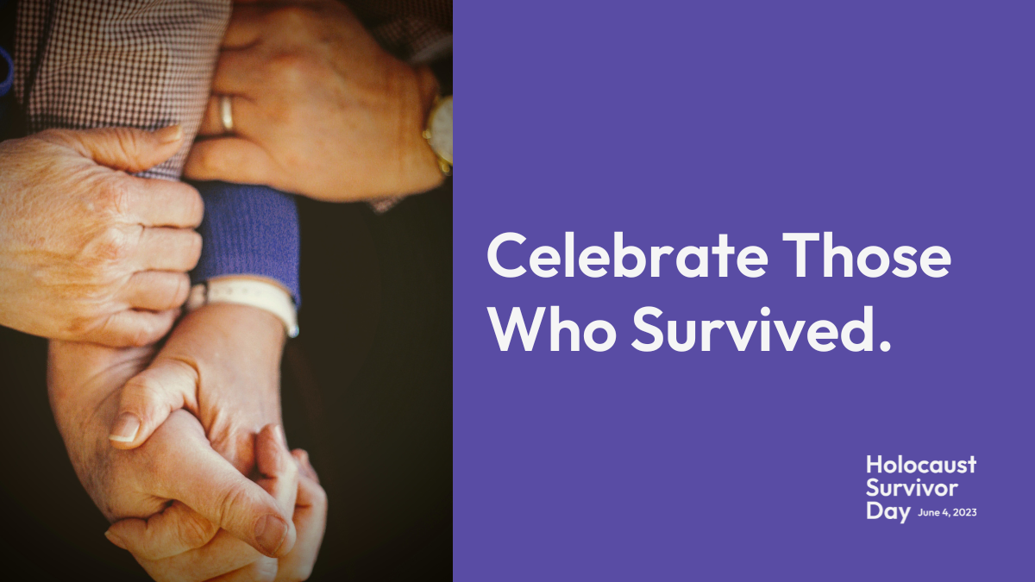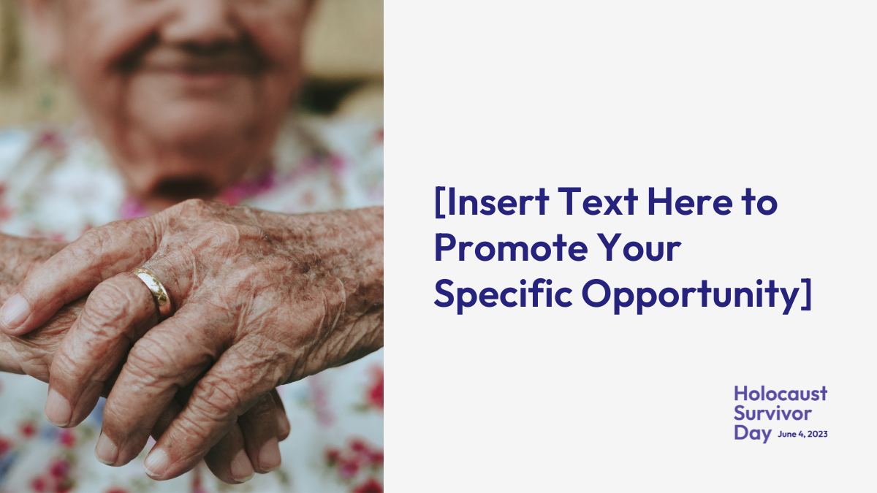
To customize these posts for your own efforts, use these templates:
Story size | Twitter/Facebook size | Instagram size | Linkedin size
Web Banners
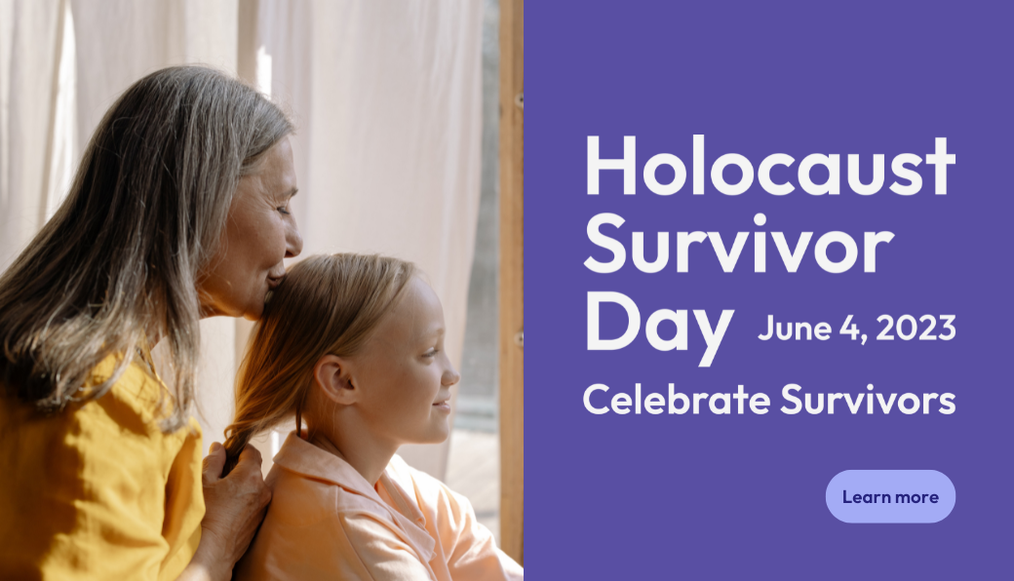
To customize these banners for your own efforts, use these templates.
Large(1040x596px) | Small(600x200px)

